* **Serial Number Tile**.

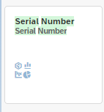

* **Stagewise-Serial Number Tracking**

